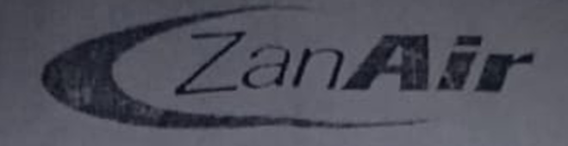
boarding pass

16/02/2021 FLIGHT B4603
DEPARTURE: 17:00

PNR 100007B0
MRS, FArMA MARZOUK KOMBO Zanzibar tc Pen.ca - Tanzania
Baggage tags:

SEQ:1

CLASS:Pemba New
